4-Aug. 2004
Test on the RdA ratios:

While working on the replies to the referees, some concerns were raised about distortions to the ratios that may be produced by the script used in the construction of the invariant yields. It was agreed that a Monte Carlo simulation would be a tool that could dispel those worries, and because the RdA paper is centered around the ratios, a test that would validate the results we submitted for publication would clear the biggest fears about the accuracy of our paper.

Several simulations were produced were the transverse momentum follows a power law distribution, and eta and phi are extracted from flat distributions. The z coordinate of the vertex was extracted from a Gaussian distribution with similar spread as the one in the real data. The tracks that go into the spectrometer were digitized and later reconstructed with the same analysis package as real data, and DST format files were written to disk.

From two sets of simulated data, each with a different value of p₀ and n in their power law distribution, a ratio shown in Fig a was calculated. In that figure, the values extracted with the script used for our publication are shown as red star markers, and the ratio of the properly normalized input power law distributions is shown as blue squares. The red data points were obtained using Peter’s method to generate acceptance maps.

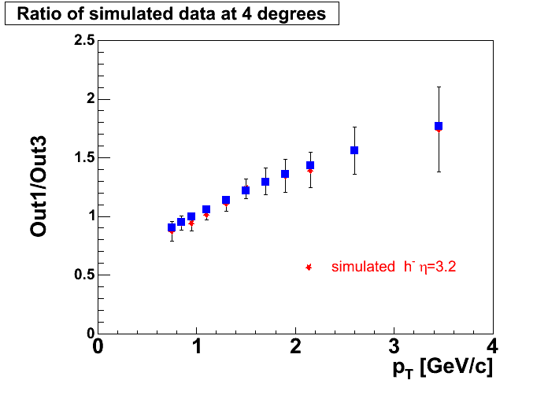
Figure 1 Ratio of invariant yields (red stars) extracted from simulated data with DstLooperTrig6.C script and Peter's acceptance method. Blue squares show the ratio of the properly normalized power law distributions used as input to the Monte Carlo.

The same exercise was done using acceptance maps produced with Claus method, the main difference with Peter’s being the fact that they guaranty the same geometry for that particular RHIC run. The extracted ratio is shown in Fig b:

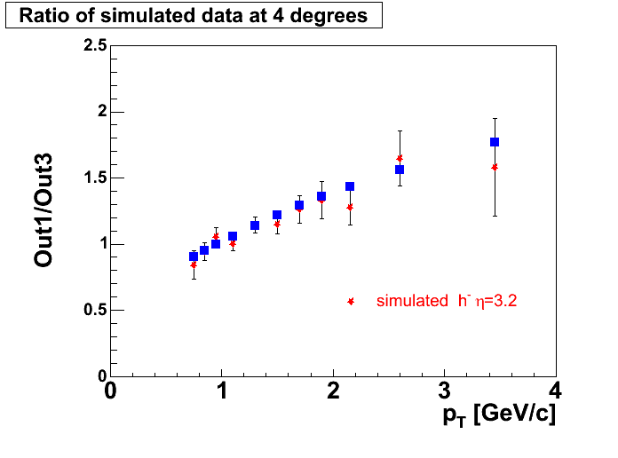
Figure 2 Ratios extracted from simulated data. Claus acceptance maps are used to calculated the invariant yields,. The fluctuations on the data points are related to the fact that only two bins of the z vertex distribution were used.

From these two figures we can conclude that the algorithm that we use to produce the RdA ratios can reproduce the input quite accurately.
But if one looks at each one of the pt distributions one can see distortions at low and high values of pt. Peter’s acceptance maps are the ones that produce the biggest distortions, as shown in the figures that follow:

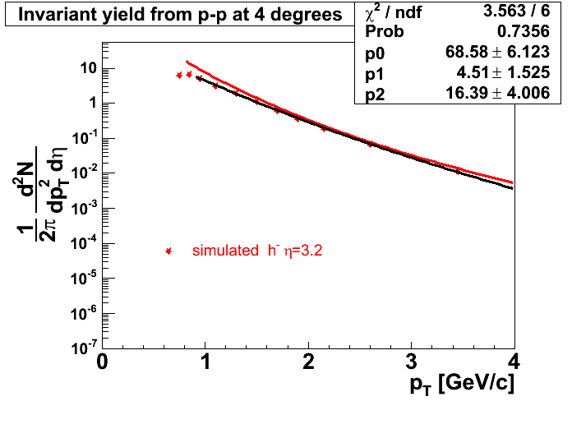
Figure 3 Red star markers show the invariant yield extracted from simulated data a power law parent distribution shown here with the red curve (p0 = 1.4 n=9.0). Parameters of a power law fit to the extracted distribution are shown on the top right panel.
The same data set processed with Claus acceptance maps produces a better agreement with the input distribution:

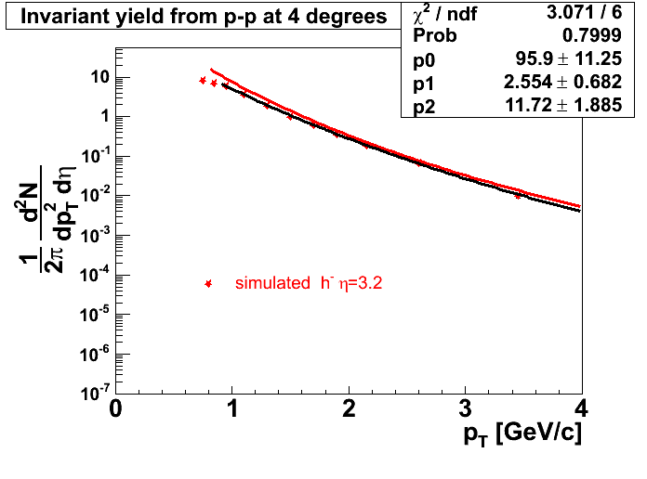
Figure 4 Invariant yield extracted from same data set as previous figure, but Claus acceptance maps are used instead of Peter's.

The best agreement between input and output was obtained from another data set were multiple scattering and decays were turned off in the Monte Carlo simulation:

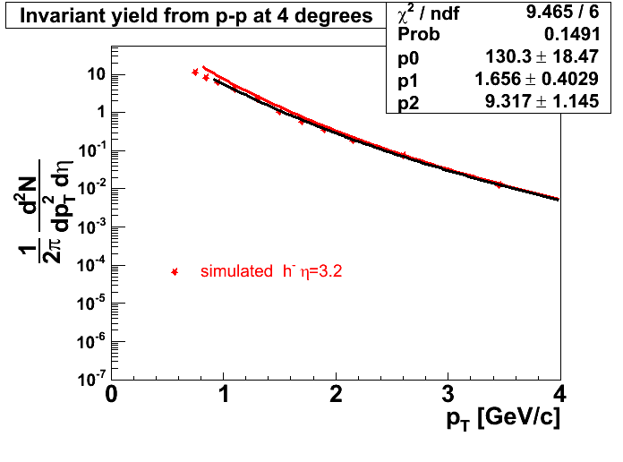
Figure 5 Invariant yield calculated from a data sample that had multiple scattering and decays turned off. This distribution was extracted using Claus acceptance methods.

As shown above this new Monte Carlo based tool to study our extraction of pt distributions is indicating that our understanding of the TPC response, our acceptance maps and the way we extract the pt distributions introduces a distortion, but that distortion is the same for similar input distributions and does not affect the RdA ratios.

Even though at this moment we do not have an explanation for the distortion at the low pt end of the spectra, the use of different field settings helps to eliminate the distortions. The following figures show spectra constructed by Flemming with Peter’s maximum likeliyhood scheme (I use the same scheme to average field settings and vertex bins) and Claus acceptance maps. His distributions are compared to the power law fit to the pp spectrum I construct at 4 degrees. Figure f and g show Flemming’s invariant yields at full and one quarter field respectively, both compared to the same function extracted from my distribution of h⁻ from pp collisions at 4 degrees.
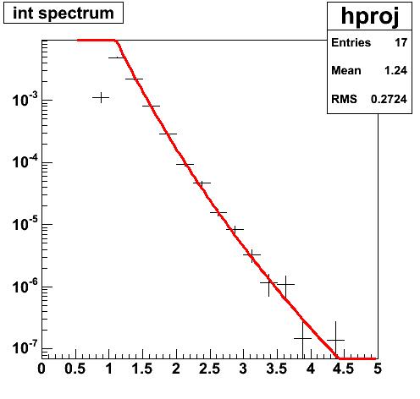
Figure 6. Flemming’s full field spectrum of h- produced at 4 degrees compared to the fit to the distribution I extract with all field settings shown as a red curve.

Figure 7 Spectrum extracted from 1/4 field runs with maximum likelihood based method and Claus acceptance maps. The green curve is the power law fit to the spectrum we plan to update in the RdA paper.
The comparison performed in the last two figures shows that the spectrum I extract with all available field settings can be reproduced by Flemming’s analysis. This should give us confidence in the results we will resubmit for publication. We will revisit the assignment of the systematic errors in our spectra (at this moment we had a fixed 15% for all values of pt) and then resume the preparation of a reply to the editor and the referees.

Replies to Referees

This document was put together to draft answers to the referee’s comments. The main objective of this document is to sketch those answers and inform the collaboration.
Action items are printed in red.

Referee A writes:

1.) The compressed scale in Fig.2 in the paper makes the quantitative
analysis of the data quite difficult. I much prefered the way the data
were presented at the DNP fall meeting and the QM conference. But after
careful checking I conclude that the data in the paper and the data
shown at the conferences are consistent. So this is just my preference
regarding plotsmanship and it should be taken as a suggestion.

This comment can be dealt by telling the referee that we post the data in table format in the public BRAHMS web page.
No change to the text.

2.) I think the paper should clearly state the pseudo-rapidity bins
that were used for the measurements rather than saying 'narrow intervals
around eta = 0,1,2.2,3.2'. How narrow ? And how does the narrowness
affect the statistics ?

The pseudo-rapidity bins can be read from the acceptance plots of figure 1
But we can tell him:
η = 0 Δη = 0.2
η= 1 Δη = 0.2
η = 2.2 Δη = 0.25
η = 3.2 Δη = 0.45
This comment seems to indicate the need to describe our acceptance corrections. This is also a question from referee B so we could prepare some typical values extracted from the acceptance maps. Are the maps roughly constant? (I think they are) what is a typical value or has it maxima? And finally say something about the error on that number (I think our value is small <1%). About the statistics: should be give as much detail as saying we have ~30 events at highest pt bin at η = 3.2 in p+p and ~100 in d+Au?

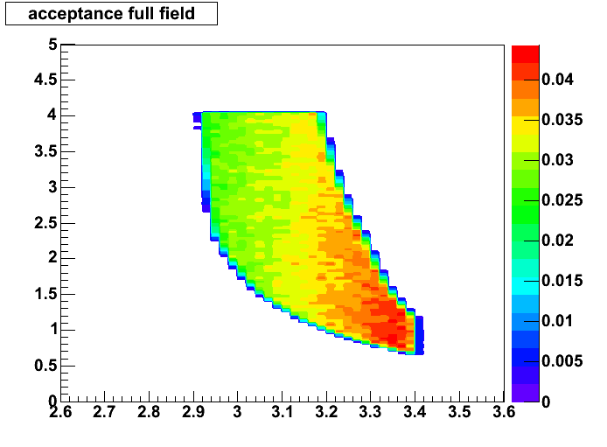
Figure 1Acceptance map at 4 degrees Full field
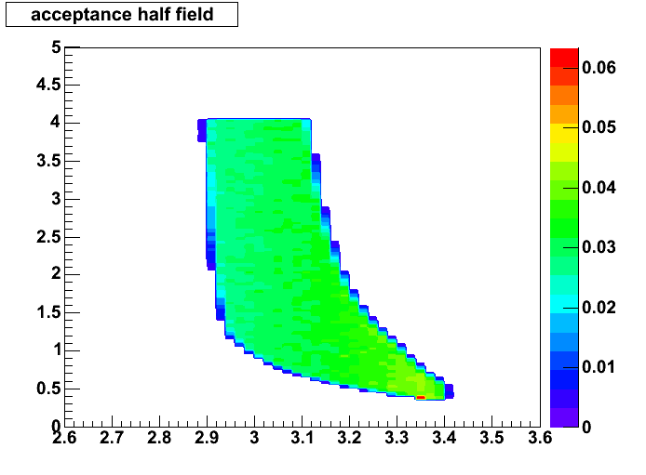
Figure 2 Acceptance map at 4degrees hafl field.
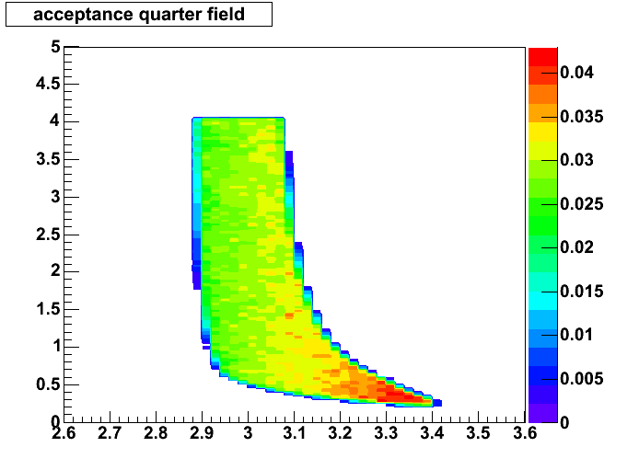
Figure 3 Acceptance map 4 degrees quarter field.
At 4 degrees the acceptance changes from 0.04 to 0.025 for all three field settings. The error at half field reads 0.0013 and is constant. The uncertainty in the acceptance corrections ranges from 3 to 5%.

I think this only requires a short addition in the text to indicate the magnitude of the acceptance correction.

3.) What are the different colored contours in the upper row of Fig.1 ?
They are neither explained in the text nor the figure caption.

Each panel shows the acceptance at some angle and different magnetic field settings. The contour line is made gray whenever the maps overlap.
The caption is correct, this may not need any change in the text.

4.) Fig.6 top: 'based on simulations the ratios calculated with negative
particles are larger in forward rapidities than the ones calculated with
the charge average.' Why ? By how much ? Is that in the systematic error
? Could it be corrected on the basis of the simulations ? Has that been
done for the data presented here ?

This may be a clarification to the referee. We did include the statement because there were questions about isospin effects and the fact that at forward rapidities we work with negative charge particles. The statement is there to say that the ratio would be even smaller if we calculated the ratio for (h⁺ + h⁻ )/2.
Why is the ratio bigger? The protons and k⁺ have a harder distribution than the pions.
By how much? We can prepare a figure.
Is that in the systematic error? No.
Can it be corrected? We would have to use the simulated positve charged distributions.
Has the correcting been done? No

We can provide a value of the difference to the referee and try to make the text clearer. Emphasize the fact that we err on the safe side. If we were to use
(h⁺ + h⁻ )/2 to calculate the ratios we would see a stronger changes at the most forward angles.

5.) Fig.6 middle: 'strong correlation between ratio of charge particle
eta densities and R(dA) values.' What does that mean ? Maybe one
sentence of explanation should be added here and not just two
references. What are the physics implications ? And how strong is that
correlation ? It seems correlation in this context is defined as the
fact that the R(dA) values in the lowest pt bin shown here reach the
dashed line. Well, the lowest pt bin shown varies from eta-bin to
eta-bin. Is there a claim that the R(dA) values would be constant below
the lowest measured bin and therefore follow the density ratio line ? Is
this an indirect argument for participant scaling at low pt ? Please add
a sentence about the physics relevance of this agreement between R(dA)
and particle density ratio.

This comparison was introduced to show that the suppression is following the same pattern as the density ratio that is mainly driven by soft physics. At that time we had some understanding that saturation would affect higher pts. Only later we learned that the suppression happens at all pts. The comparison is now more of a consistency between two independent measurements.
In my opinion the physics relevance of the agreement is poor.
I suggest we tell that to the referee and try to leave the text as is.

6.) Fig.7 end of first paragraph: 'the functional form of the c-to-p
ratio is close to that of the saturation scale.' Which functional form
of the saturation scale ? The one shown on page 3: Q**2 prop. e(Lambda
y) ? So Lambda is 0.2-0.3 based on HERA data and alpha on page 7 is
-0.28 based on BRAHMS data. Is that the connection ? Please elaborate by
adding one sentence of explanation. Also, the saturation scale in HERA
is measured in rapidity not in pseudorapidity. Wouldn't that cause a
difference to the functional form at very forward rapidities ?

Yes we found interesting that the Rcp from our sample of central events averaged from 2.5 to 4.0 GeV/c has the same rapidity dependence as the saturation scale Q^2 shown in page 3. We state at the end of the paragraph that this similarity only appears for central events.
We know now that 70% of the charged particles are pions whose pseudo-rapidities are practically equal to their rapidity, that is why we think we can mix both quantities.

7.) Fig.8 in the summary: a.) 'results are consistent with a
modification of the Gold wave function'. I am not sure whether the 'Gold
wave function' here is not too generic a term. I am not really sure what
the authors mean by modification to the Gold wave function. b.) next
sentence: 'such modifications produced a suppression at all values of pt
similar to the multiplicity density ratio.' So this goes even further
than the statement in the text to Fig.2 where it was stated that the
R(dA) values reach the particle density ratios at low pt. Here now the
modifications is the same for all pt's. I guess this relates to the
solid symbols in the last panel of Fig.3. Again, the relation between
particle density and suppression factor is not explained. Is the fact
that for this bin the R(dA) are near constant an indication of an
initial state effect ? How does this relate to the statement in the text
about Fig.2 ? c.) I think the final sentence of the paper should be
taken out because it states a preference in the interpretation of the
data that can not yet be unambiguously corroborated. The paper nicely
states the alternate HIJING based approach that utilizes increased gluon
shadowing. Maybe the difference between color glass condensate and
strong gluon shadowing is just semantics, but I would not claim evidence
for gluon saturation on the basis of this measurement alone. The data
are very exciting in their own right and do not require a statement by
the experimentalists on the ongoing model controversy.

a) The use of the term "Gold wave function" in the context of this paper refers to a description of the gold ion at the parton level. Something like a Parton Distribution function of the entire gold nuclei.
b) we are saying that our results are consistent with CGC. Where there is saturation at eta=0 and further deviations from p+p collisions as one goes to forward rapidities and these deviations occur at all measured values of pt. The near constant value of the Rcp from central events at eta = 3.2 is not of interest in our opinion, we consider the fact that it's value is consistently smaller (at all values of pt) than the ones calculated at the other pseudo-rapidities the heart of our results: a suppression that has its higher value at forward rapidities and for the most central events.
To avoid the impression that our results settles an ongoing debate, we will change the last sentence to the following:

"The results presented in this letter have generated strong interest in forward physics at RHIC and the possible relevance of these measurements to the onset of saturation at RHIC is under discussion"

Referee B writes:

The most important issue to be addressed is that the data shown in figures
1, 2 and 3 do not appear to be consistent. The main message of the paper, a
decrease in particle yield in dAu compared to pp with increasing rapidity,
is clearly visible in figure 3. However, in figure 2 the suppression effect
appears to be significant only at the approximately 2 sigma level.

We read figure 2 as a gradual change with rapidity not as point by point deviations from the value of 1, but as an overall change. At eta=0 we see an enhancement similar to the so called Cronin effect measured at lower energies in fixed target experiments, as the pseudo-rapidity changes the RdAu ratio such enhancement changes into a suppression.

The nuclear modification factor from the yield ratio in central to peripheral
collisions has been observed to exceed the nuclear modification factor
calculated by comparing to p+p collisions. Indeed this is the case for the
data in this paper at pseudorapidity 0 and 1 and at low pT for more forward
rapidities. However, for high pT at forward angles the trend appears
reversed.
When we compare the RdAu ratio with the semi-central Rcp we get agreement within errors as shown in the figure below:

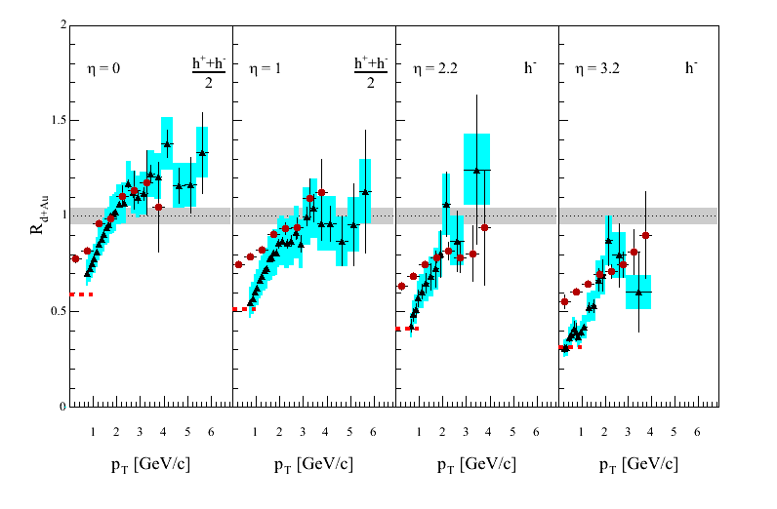
Figure 4 Comparison of RdAu and Rcp for semi-central events.

Within errors I do not see the a real disagreement between RdAu and Rcp except at low pt where the difference may come from the fact that the peripheral sample used for the Rcp denominator is related to an average 3.3 binary collisions instead of a single collision in p+p.
If we compare the Rcp corresponding to our most central events we see a very clear change of trend as you mention above. This change of trend may be the most important result presented in this letter.

This may not need any action, it looks like he was checking the consistency between the plots.

“This prompted me to attempt to recalculate RdAu in figure 2 from
the spectra in Figure 1 using equation 1 and the given value of <Ncoll> =
7.2. I was able to reproduce plotted RdAu values for the three lower rapdity
bins. However, the rightmost panel of figure 2 is simply not consistent at
higher pT with the spectra presented in figure 1 for negatively charged
particles at pseudorapidity = 3.2! At the highest pT bin, the d+Au spectrum
actually falls below that in p+p, yet the RdAu reported in Fig.2 for that pT
bin is not the smallest value for pseudorapidity = 3.2. It is not possible
for this reviewer to determine whether Figure 2 is incorrect or Figure 1 is
incorrect, but one of them must be.”

He is right! We constructed the ratio at η=3.2 (shown in figure 2) from two sets of data 1/4 and 1/1 field runs. We did that because we were missing the 1/2 field setting for the d+Au runs and the ratios made from spectra extracted from all available data showed an awful discontinuity around p_{T}=1.GeV/c.
But we constructed our p_{T} distributions by combining all the data available.

I explored the p+p spectrum because it is the one that shows the biggest differences at high pt depending on what field settings are used and reached the conclusions that the 1/4 and 1/2 field settings distort the high end of the distribution because the momentum resolution becomes so poor beyond some value of momentum that it moves events to higher pt bins producing a harder distributions. The conditions I imposed are the easiest I can come up at this moment and they are based on the upper limit in momentum:

Higher p accepted = 2 X Reference momentum. With the reference momentum being equal to 23.6 GeV/c at full field.

P_{T} < 1.0 GeV/c at 1/4 field and
P_{T} < 2.0 GeV/c at 1/2 field.

I know that we should apply cuts in momentum and also recalculate the acceptance to reflect those cuts. For the moment I think the cuts I have applied show that including the cuts put us in the right path.

I recalculated the invariant yields for d+Au and p+p at η =3.2 using the version 9 of the DST’s (updated magnetic field values) and I checked that the averaging of all settings (z vertex bins and magnetic fields) is done the same way: the weights used are defined as:

Weight = acc / Σ acc
In the figures that follow we display new ratios as they were produced in time. In figure 5 the ratios were calculated with spectra extracted with averages on pt eta bins that had counts on them. We have since then agreed that the correct algorithm should include empty bins in the average, the ratio obtained with that algorithm is shown in figure 6:

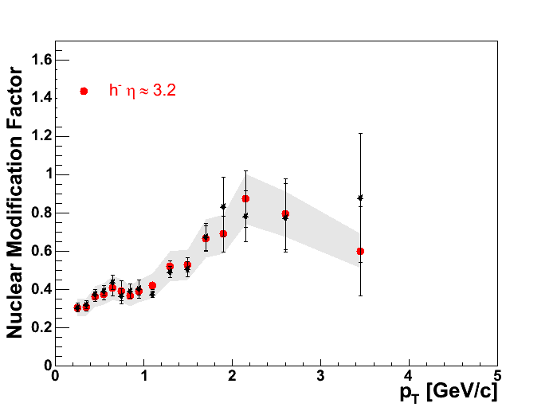
Figure 5 The red points are the ones we submitted in the paper. The black points are obtained by making the ratio of the invariant yields obtained with all available field settings and the pt cuts that should eliminate the distortions at the high end of the distribution. These ratio was obtained excluding pt eta bins without counts.

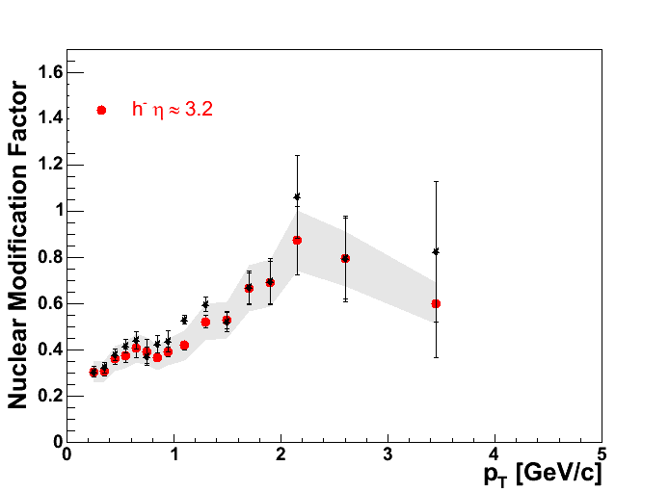
Figure 6 RdAu ratio calculated with the algorithm that includes empty pt eta bins. The spectrum for the denominator was extracted from 1/4, 1/2 and full field settings.

Most recently, while discussing how to include the distortions that the algorithm introduces in the pt distributions, we decided to investigate making the ratio with the same set of field settings. Figure 7 shows the RdAu ratio at 4 degrees calculated with pt distributions extracted from 1/4 and full field settings:

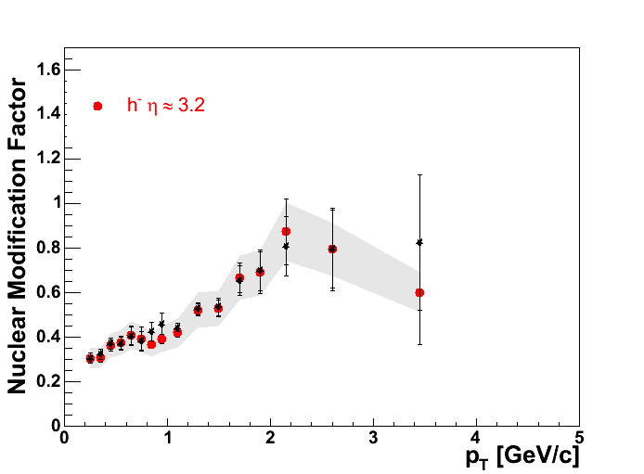
Figure 7 Ratio calculated with the same field settings in numerator and denominator.

The ratio is reproduced within errors with the exception of the last point at ~3.5 GeV/c that we now is the result of the inclusion of empty bins in the averages.
This time it looks like the analysis of real data shows the same cancellation of the distortions introduced in the spectra that we found while working with simulated data.
I would then suggest that the way to proceed is to make ratios from data sets that have identical field settings. We would then resubmit the paper with the ratio shown in figure 7 and the p+p spectrum at 4 degrees will also be extracted from 1/4 and full field settings.

The invariant yields are different and figure 1 would now look as the figure below:

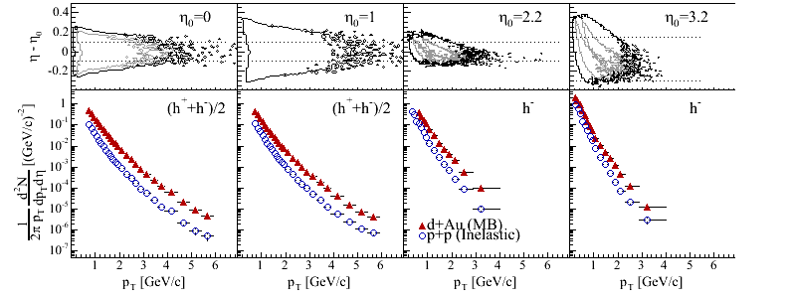
Figure 8 New version for figure 1 of the paper

The spectra shown in figure 1 and the ones used to calculate the ratio were not identical. The data sets are the same but the cuts applied during the extraction of the invariant yields were not the same and the spectra shown in the panel corresponding to eta=3.2 in figure 1 are distorted specially at the high pt end both for d+Au and p+p..

We will start with a letter to the editor where the first point will indicate that the paper emphasizes the ratios and that the spectra at eta=3.2 were wrong; the spectra shown in figure 1 and the ones used to calculate the ratio shown in figure 2 were not identical. The data sets are the same but the cuts applied during the extraction of the invariant yields were not. The spectra shown in the panel corresponding to eta=3.2 in figure 1 are distorted specially at the high pt end for p+p collisions.

The ratio of the new invariant yield from d+Au over the old one is shown in Figure 6 . The difference between spectra in this case comes from the inclusion of empty bins whenever we average the yields calculated from 1/4 and full field.

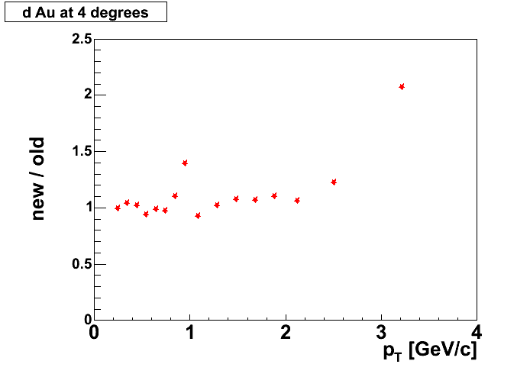
Figure 9 Comparison of new spectrum from d+Au and the one we submitted with the paper.

a similar ratio is calculated for p+p and is shown in figure 7. The main contribution to the difference comes this time from the poor momentum resolution of 1/4 and half field filling bins at high pt that make the spectrum harder once the average of all field settings is done.

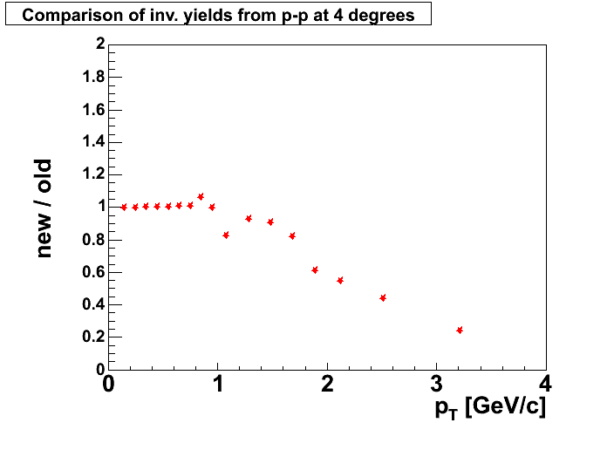
Figure 10 Comparison between the new p+p invariant yield at 4 degrees and the one submitted with the paper.
We can also compare the spectra used to calculate the submitted ratios and the new one:
Figure 8 shows that ratio of the new distribution and the1/4 field alone that was used to calculate the original ratio.

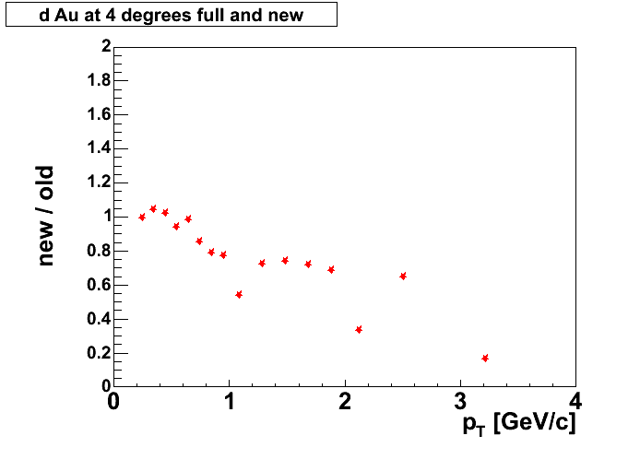
Figure 11 Ratio of new spectrum to old 1/4 field alone

The same ratio but this time comparing to the full field setting alone.

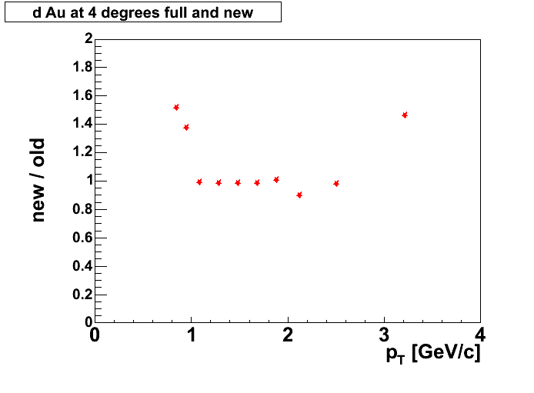
Figure 12 Comparison of new yield to old full field yield.
Similar excersize is done for p+p:

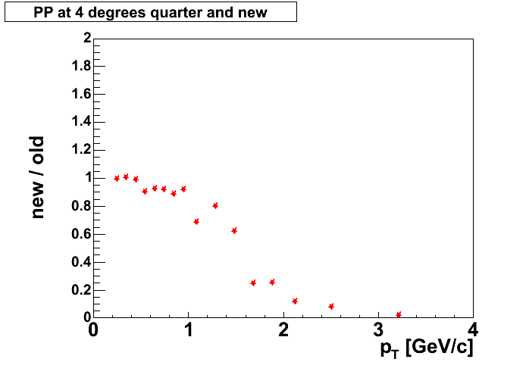
Figure 13 Comparison of new p+p yield to the yield from 1/4 field alone used to calculate the ratio.
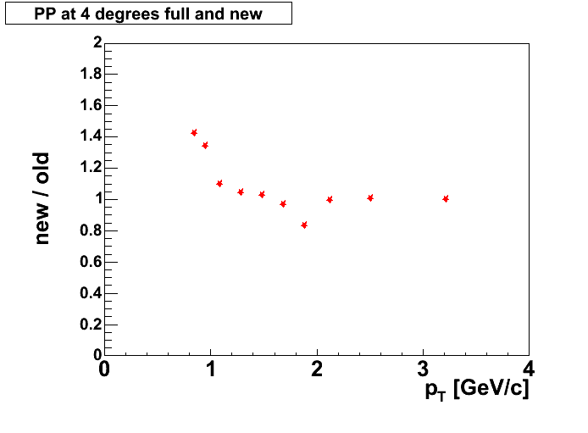
Figure 14 Comparison of new p+p spectrum to the old full field spectrum used to make the submitted ratio.
If we apply cuts in pt to extract distributions at eta = 3.2 we should be consistent and apply similar cuts at 12 degrees. The same condition (2 X Ref. Momentum) translates into:
Pt< 2.45 GeV/c
But that happens to be in the middle of the 17th pt bin, I decided to use instead:
Pt < 2.3 GeV/c

The RdAu ratio at 12 degrees calculated from version 9 of the DSTs and the new cuts is shown in figure 13.

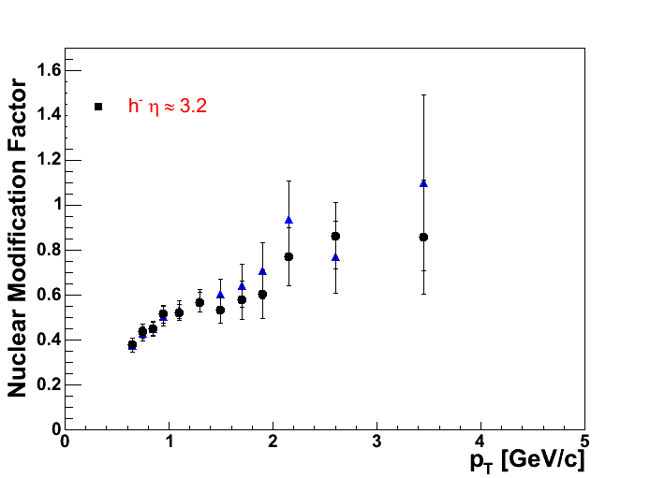
Figure 15 Blue triangles show the RdAu ratio submited with the paper, the black symbols show the same ratio calculated with version 9 DST and upper cut in pt in the 1/4 field setting.

A comparison between the submitted spectrum for d+Au and the one including the pt cuts is shown as a ratio in figure 14:

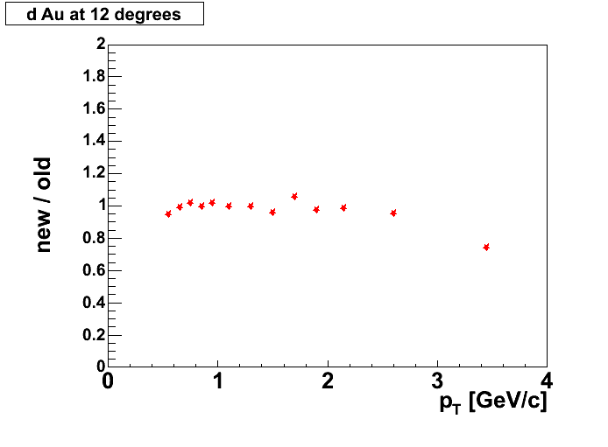
Figure 16 Comparison of the new invariant yield for d+Au collisions at 12 degrees and the one submitted in the paper.

The same comparison, but this time for p+p collisions is shown in figure 15:

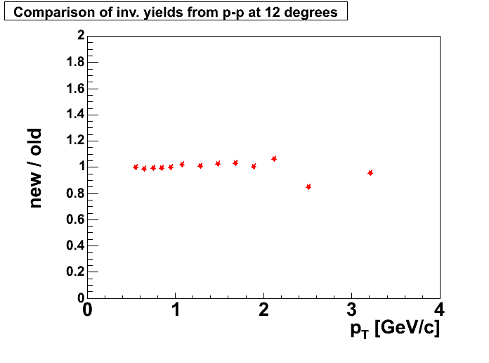
Figure 17 Comparison between the new yield for p+p at 12 degrees and the one submitted with the paper.
Looking at the spectrometer
acceptance plot in the upper part of figure 1, one notes that the acceptance
at this setting is quite tiny. Furthermore, based upon the figure, the small
acceptance results in few particles measured, which must cause considerable
uncertainty on the acceptance correction. Undoubtedly many Monte Carlo
events were generated to study this, however, the reader is given no measure
of how well this correction has been determined. Since the acceptance
correction clearly must be very large, the authors need to recheck that this
is done properly, state the magnitude of the correction and the uncertainty
on it. It is very difficult to accept that the systematic uncertainty on the
forward spectra at high pT in Fig. 1 is the same 15% as where the
spectrometer acceptance is large and easily determined. In the ratio of d+Au
to p+p collisions, much of this uncertainty may be expected to cancel.
However, it is clear that this ratio will still reflect residual
uncertainties in the reproducibility of positioning the forward spectrometer
at 4 degrees. The authors should state the magnitude of this uncertainty
explicitly, as the main conclusion of the paper rests so heavily on this
spectrometer angle.

Same reply as the one to referee A we need some numbers. And point to the fact that as you go forward the acceptance increases because bigger delta phi.

As it is so important to the conclusion of the paper, which may be the first
observation of gluon saturation in nuclear collisions, further clarification
is needed for figure 3, as well. Because the suppression is more apparent in
this variable, it is important to also publish the centrality selected
spectra upon which this ratio is based. The statistical errors on the
minimum bias spectra are not visible in figure 1, and the shape as well as
value of the nuclear modification factor is very different in figures 3 and
2. I would therefore like to see the paper include the centrality selected
spectra, perhaps as a second set of panels to Fig. 3.

Here we have to explain to the referee that Rcp are not calculated as ratios of spectra, but rather as ratios of counts in η and pt bins.

In the physics discussion in the last two paragraphs of the paper, there are
several issues, as well. The penultimate paragraph discusses two models
incorporating related, but quantitatively different, physics assumptions.
However, it does not give a clear message to the reader. Do the data prove
that one model is closer to the truth than the other? The concluding
paragraph appears to indicate that this is the case, but includes a sentence
whose meaning I was unable to figure out. Can the authors please replace
this sentence "Such modification produces a suppression at all values of pT
similar to the one observed when comparing multiplicity densities." with
something simpler and clearer? Presumably "the one observed" refers to the
amount of suppression, not the pT values... ? Also, for the general reader
of PRL, it would be useful if the pT range in which suppression is observed
were related back to the value of Q_s expected for the relevant rapidity
range to support conclusions about the gold wavefunction at small x.

We think that the rapidity and centrality dependence of our results are consistently explained by a description that includes the onset of saturation and the effects of quantum evolution at high rapidity, but as pointed by Referee A it may not be up to us to settle a discussion that has only began. We will thus
change the last paragraph of our summary "While the theoretical framework ....." to:
emphasize the “suppression at all values of pt” and refer again to KKT reference.

We should work on the conclusions in order to emphasize the measurement and not to the theory.

